SIMATS ENGINEERING
ASSESSMENT TOOL 2

COURSE CODE: ITA0601 COURSE NAME: MACHINE LEARNING

COURSE OUTCOME COVERED

CO1: Learning Problems, Perspectives and Issues, Concept Learning, Version Spaces & Candidate Elimination, Inductive Bias, Decision Tree Learning, Representation & Heuristic Search (BL1, BL2)

Assessment Tool Weightage: 20%
QUESTIONS: 15 Total Marks: 25

Annexure A
CONCEPT MAPPING
Code of Conduct:
I ___S.Sri Sai Prasanna Durga (192424241)_ (Name / Reg No) certify that this submission is my original work and that I have adhered to the guidelines specified for this assessment.
I understand that any violation of academic integrity rules will result in disciplinary action.

Signature of the student:

1.Design a machine learning system for disaster management to predict events such as floods and earthquakes using historical and real-time data. Explain the choice of model, data preprocessing, and feature selection techniques.
(a) Describe the steps involved in training, validating, and evaluating the model.
(b) Explain how the system can assist in early warning and emergency response.
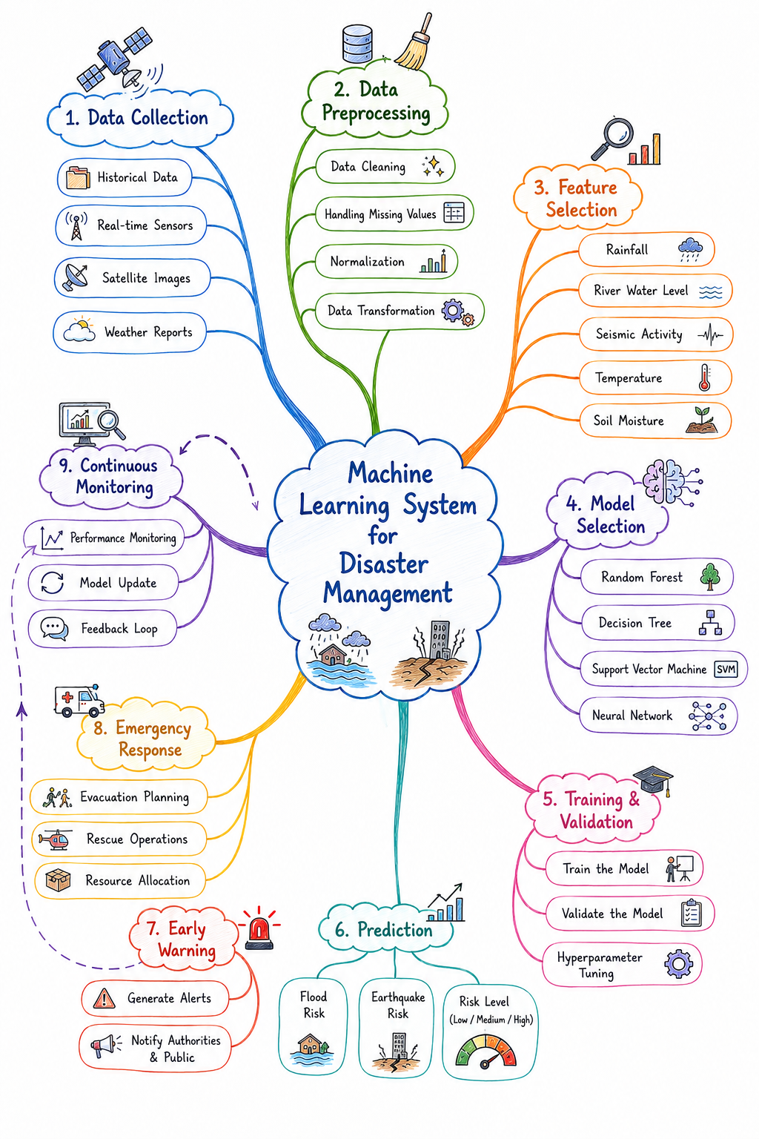
2. In the context of the Find-S algorithm, consider the dataset used to determine whether a customer will buy a product based on attributes such as Age, Income, Student, and Credit Rating. Apply the Find-S algorithm to determine the maximally specific hypothesis. Show step-by-step updates after each positive example and ignore negative examples. Finally, provide the final hypothesis.
Dataset:
Example | Age | Income | Student | Credit Rating | Buys Product
1 | Young | High | No | Fair | No
2 | Young | High | No | Excellent | No
3 | Middle | High | No | Fair | Yes
4 | Senior | Medium | No | Fair | Yes

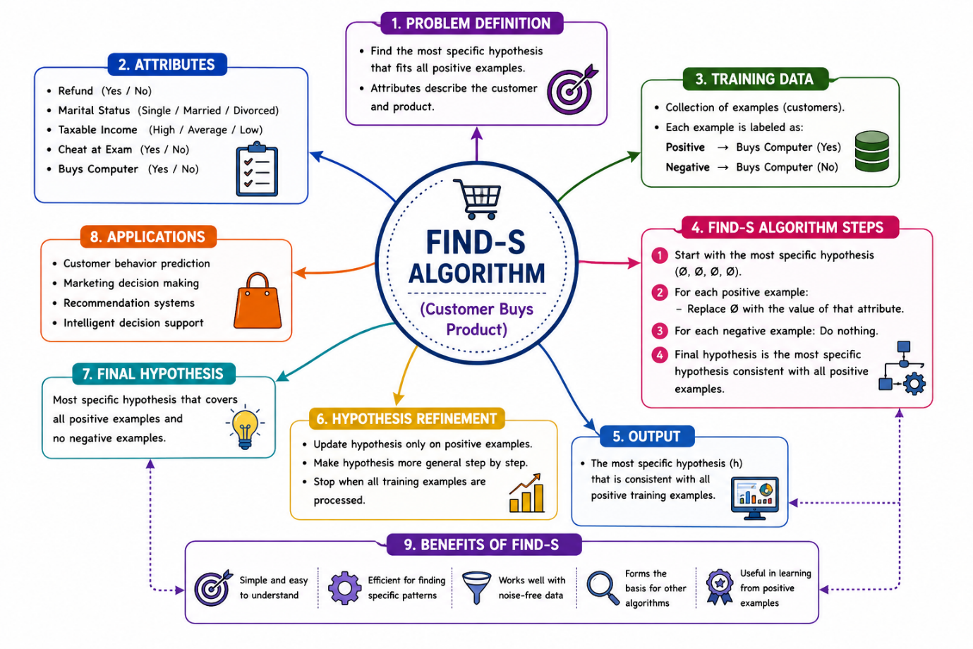
3. Design a machine learning system for health analysis to predict diseases such as heart disease or diabetes using patient data including age, blood pressure, glucose level, and lifestyle factors. Explain the choice of suitable algorithms and justify their selection. Describe the steps involved in data preprocessing, feature selection, and model training to ensure accurate and reliable predictions.
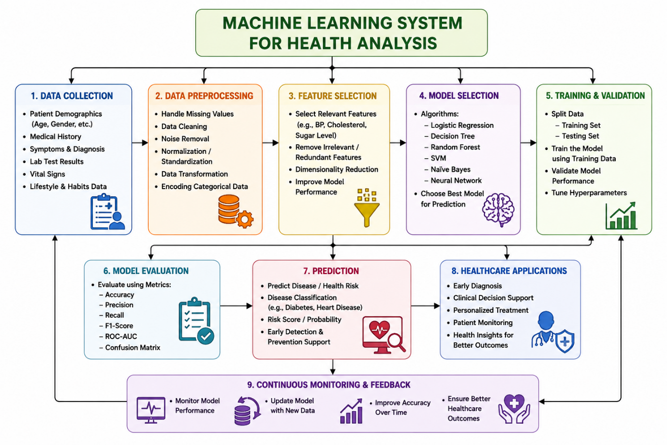
4.Explain the concept of clustering in unsupervised learning.
(a) Describe the working of the K-Means algorithm with a step-by-step example.
(b) Explain how the value of K is chosen using the Elbow Method.
(c) Compare K-Means with Hierarchical Clustering.
